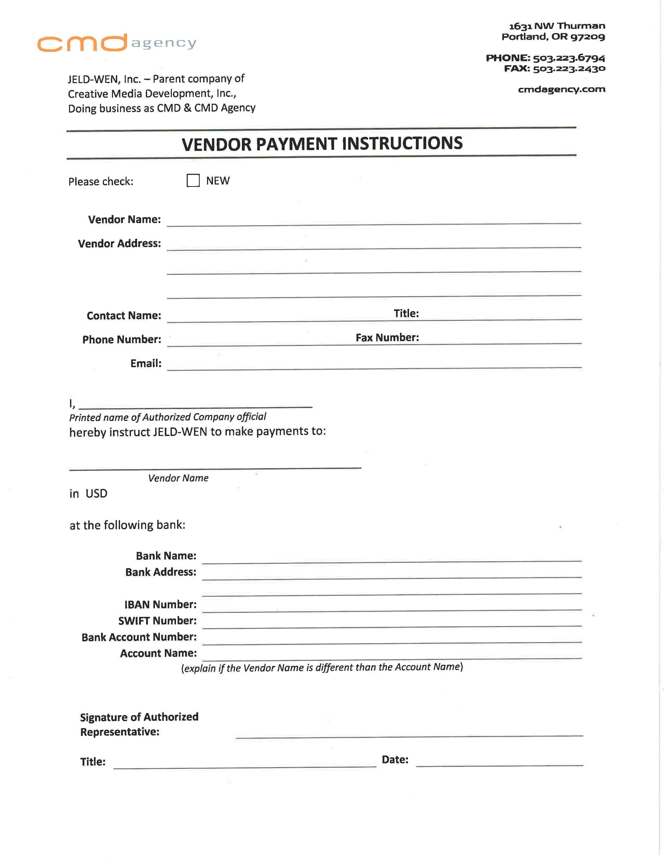



Shubhajit Saha June 8, 2012

Shubhajit Saha

60, Sadar Buxi lane. Howrah – 711101, West Bengal. India

**Mailing Address**: Ubisoft Entertainment India Pvt. Ltd.

Kumar Cerebrum Building-3, Level-6. Kalyaninagar, Pune – 411006. India

Shubhajit Saha

+91-9970186882

shubhajit.saha2@gmail.com

Shubhajit Saha

Axis Bank

Marigold Premises, Ground Floor, Survey No. 15 Vadgaonsheri,

Kalyani Nagar, Pune 411 014, Maharashtra. India.

AXISINBB002

911010046043425

Shubhajit Saha